52

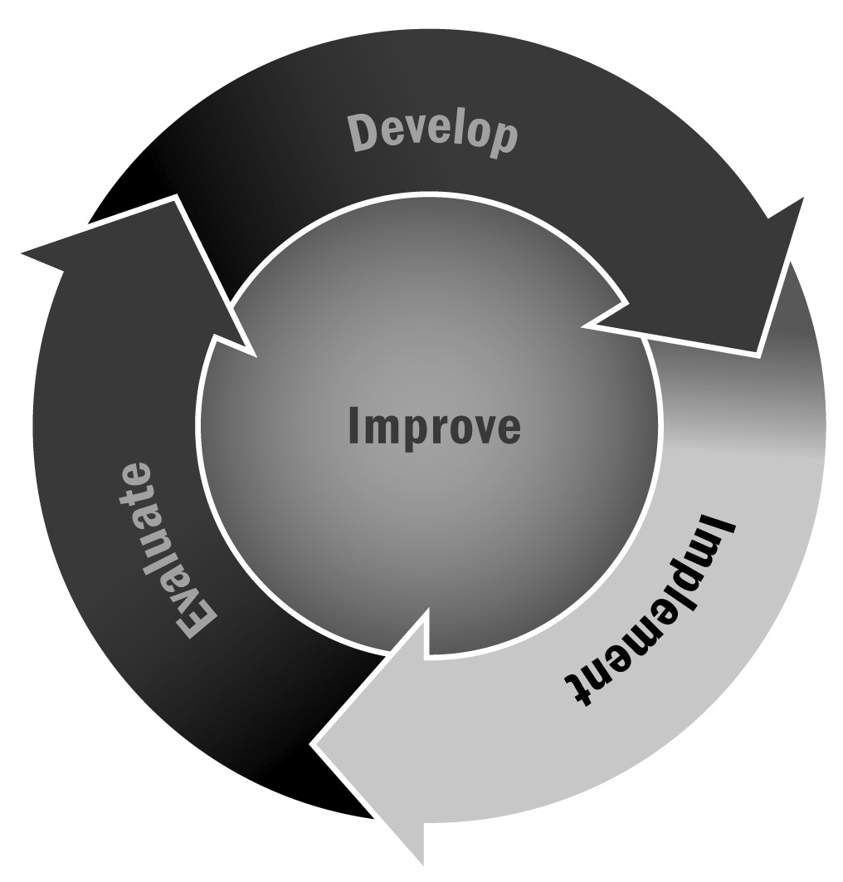
Field Trip Permission Form
In Chapter 3, you learned about the importance of aligning your activities with the information being covered during the school day. Building on school day lessons will help your program align with the school day and can provide a real-world application for your participants.
Directions: Below is a sample permission slip that you can use or adapt for your own afterschool and expanded learning program.

Dear Family Member:
Your child has chosen to participate in the following activity:
Activity: |  |  |  |  |  |  |  | Location:
Date:
Departure time: |  |  |  |  |  |  |  | Location:
Mode of travel:
Return time: |  |  |  |  |  |  |  | Location:
[If there is a fee] There is a |  |  |  |  |  |  | fee for this activity.
Please return the form below with cash or a check payable to

(Please detach and return)
Itinerary Information
I give my permission for _______________________________________ [young person’s name] to participate in the [program name] on _________________ [date].
Contact _______________________________________ in the event of emergency.
Phone Number: ____________________________________________________
Health Release
I give permission for the activity leader in charge to act on my behalf to take necessary measures in the event of sickness or injury during the field trip. I agree to pay for any medical expenses for my child (named above).
Current medical conditions
(including allergies) or medication:
Insurance Company:
Policy No.: |  |  |  | Policyholder’s Name:
Signature: |  |  |  | Date:

